Re-Do Lab Assignment: Lab 1: Acceleration Due to Gravity

Title Author: Misbah Ahmed Nauman

CCID: misbahah

Student ID: 1830574

Lab Partner(s): None

EN PH 131, ET23

TA: Kiril Kolevski

Date of Re-Do Lab: 04/02/2024

Introduction:
The key objective of this lab is to experimentally determine the acceleration due to gravity using a tennis ball and the tracker software. By mimicking the famous anecdote of the falling apple, we aim to use a cellphone and tracker software, to measure the acceleration due to gravity. The specific goals of this experiment include experimentally determining the acceleration due to gravity using data obtained from the motion of a falling tennis ball, determining the degree of accuracy to which the cellphone and tracker software record data, and understanding the relationship between position, velocity, and time for a falling object, and using this understanding to calculate the acceleration due to gravity.
According to the lab manual [1] provided to us, the theoretical value for the acceleration due to gravity is g = 9.81 m/s². We will determine an experimental value for g in this experiment and compare it to the theoretical value given. In addition to this, we will evaluate how effective the cellphone and tracker software are in producing accurate results.
The camera on the phone works by capturing light through sensors to create clear images. However, when recording moving objects, it can lead to motion blur. This blur, though not easily noticeable in the video itself, becomes visible when examining individual frames using tracker software. This motion blur could potentially affect our ability to accurately calculate the acceleration due to gravity.
We will compare the motion of the falling tennis ball to what we expect from the theory of projectile motion ^{[1]}, which predicts
$y=y_{0}+v_{0,y}t-\frac{1}{2}gt^{2}$ Eq. 1.1
and
$v_{y}=v_{0,y}-gt$ Eq. 1.2
where, y is the vertical position of the ball (in m), $y_{0}$ is the initial position of the ball (in m), $v_{0,y}$ is the initial vertical velocity component of the ball (in m/s), g is the acceleration due to gravity (in m/s²), t indicates the specific time of the motion of the ball (in s), and $v_{y}$ is the vertical component of the velocity of the ball (in m/s).
Methods:
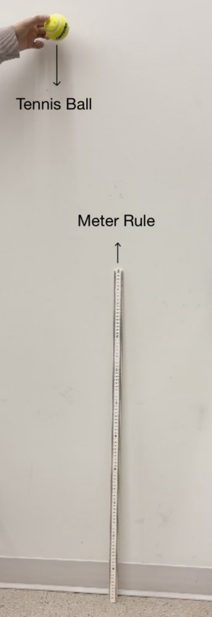
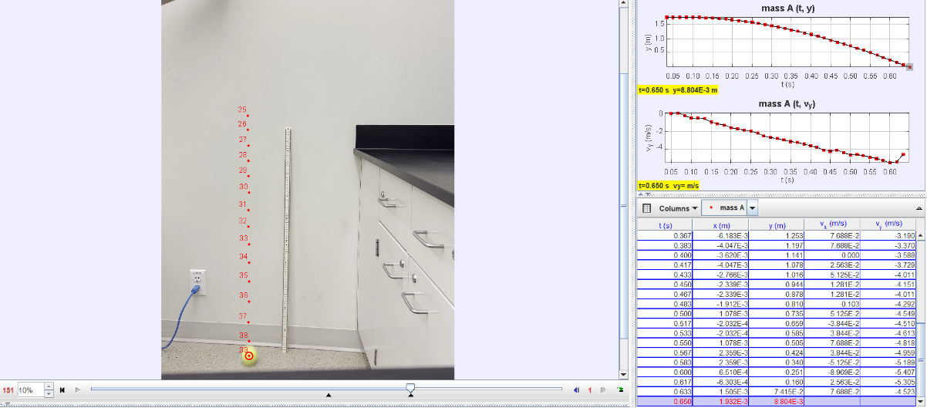
Fig. 1.2: A screenshot of the tracker software used to track the motion of the tennis ball. The individual red dots (•) represent the position of the ball in each frame of the video. The tracker software computes and provides data for the vertical position and vertical component of velocity during each time frame, which is then used to plot out Fig 1.3, 1.4 and 1.5.

Fig. 1.1: A picture of the experimental setup used. The meter rule was used as a calibration stick for the tracker software and the tennis ball was the object whose motion was studied. The ball was dropped with no initial velocity.
In this experiment, the equipment used included a meter rule, cellphone, tennis ball, and tracker software. The meter rule was used as a reference for measurements in the software, while the cellphone recorded the video of the falling tennis ball. To begin the experiment, the tennis ball was held a little over a meter above the ground and then dropped without any initial velocity. The video recording captured the ball's motion until it hit the ground. This process was repeated to ensure a clear and aligned video of the falling ball was obtained for analysis.
For the procedure, the recorded video was transferred to a computer for analysis using tracker software. The video was imported into the software, and a point mass was tracked frame by frame, focusing on the bottom part of the ball as a reference point. Calibration tools were used to set the length scale using the meter rule, and a reference axis were added to align the ball's motion nearly straight with the y-axis. The output data-table by the tracker software that includes time, position, and velocity of the ball, as seen on Fig. 1.2, was then copied to MS Excel for further calculations and computation of graphs.
Results:
Table 1.1: Sample data table of the Time - t (in s), Y-position - y (in m), Y-velocity - $v_{y}$ (in m/s) and $\frac{1}{2}t^{2}$ (in s²). Time, Y-
position, and Y-velocity were measured using the tracker software based on the relative motion of the tennis ball. $\frac{1}{2}t^{2}$ was calculated to be used in Fig. 1.4. The “Y-position, y (in m)” column contains the recorded data to be plotted on the y-axis of Fig. 1.3 and the “Time, t (in s)” column contains the recorded data to be plotted on the x-axis of Fig. 1.3. The “Y-position, y (in m)” column contains the recorded data to be plotted on the y-axis of Fig. 1.4 and the “$\frac{1}{2}t^{2}$ (in s²)” column contains calculated data to be plotted on the x-axis of Fig. 1.4. The “Y-velocity, $v_{y}$ (in m/s)” column contains the recorded data to be plotted on the y-axis of Fig. 1.5 and the “Time, t (in s)” column contains the recorded data to be plotted on the x-axis of Fig. 1.5. The full table can be found in the Appendix.
Time, t (in s) | Y-position, y (in m) | Y-velocity, $v_{y}$ (in m/s) | $\frac{1}{2}t^{2}$ (in s²)
0.0330 | 1.75 | 0.00 | 0.000545
0.0500 | 1.75 | -0.0493 | 0.00125
0.0670 | 1.75 | 0.0685 | 0.00224
0.0830 | 1.75 | -0.228 | 0.00344
0.100 | 1.74 | -0.502 | 0.00500
0.117 | 1.73 | -0.502 | 0.00684
0.133 | 1.73 | -0.594 | 0.00884
0.150 | 1.72 | -0.936 | 0.0113
0.167 | 1.70 | -1.14 | 0.0139
0.183 | 1.68 | -1.28 | 0.0167

Sample Calculations: (for row 1 of Table 1.1)
$\frac{1}{2}t^{2}$ = $\frac{1}{2}×(0.0330)$² = 0.000545 s²

Fig. 1.3: A parabolic graph that shows the relationship between Y-position and Time. This data is linearized using Eq. 1.1 in Fig. 1.4 to obtain acceleration due to gravity.

Fig. 1.4: A linearized graph that shows the relationship between Y-position and $\frac{1}{2}t^{2}$ using Eq. 1.1. A trendline of best-fit is displayed with the equation y = -8.58 + 1.81. Using the LINEST function in MS Excel, we determined that slope = (-8.58 $±$ 0.06) m/s² and y-intercept = (1.810 $±$ 0.005) m.
The slope represents acceleration due to gravity according to Eq. 1.1. Hence, the experimental value for acceleration due to gravity, g = (8.58 $±$ 0.06) m/s². The y-intercept represents the initial position according to Eq. 1.1. Hence, the experimental value for initial position, $y_{0}$ = (1.810 $±$ 0.005) m.

Fig. 1.5: A linearized graph that shows the relationship between Y-velocity and Time using Eq. 1.2. A trendline of best-fit is displayed with the equation y = -9.51 + 0.397. Using the LINEST function in MS Excel, we determined that slope = (-9.5 $±$ 0.2) m/s² and y-intercept = (0.40 $±$ 0.08) m/s.
The slope represents acceleration due to gravity according to Eq. 1.2. Hence, the experimental value for acceleration due to gravity, g = (9.5 $±$ 0.2) m/s². The y-intercept represents the initial vertical velocity component according to Eq. 1.2. Hence, the experimental value for initial vertical velocity component, $v_{0,y}$= (0.40 $±$ 0.08) m/s.
Discussion:
The experimental value for acceleration due to gravity obtained through Fig. 1.4 is g = (8.58 $±$ 0.06) m/s², which is more than three error intervals away from the theoretical value for acceleration due to gravity which is g = 9.81 m/s². Hence, this is in poor agreement.
The experimental value for acceleration due to gravity obtained through Fig. 1.5 is g = (9.5 $±$ 0.2) m/s², which is within two error intervals away from the theoretical value for acceleration due to gravity which is g = 9.81 m/s². Hence, this is in modest agreement.
The experimental value for initial velocity obtained through Fig. 1.5 is , $v_{0,y}$= (0.40 $±$ 0.08) m/s, which is more than three error intervals away from the theoretical value for initial velocity which is $v_{0,y}$= 0 m/s. Hence, this is in poor agreement.
Our experiment helped us understand how gravity affects falling objects. We measured the acceleration due to gravity and found it to be 8.58 m/s² and 9.50 m/s². This was a bit different from the expected value of 9.81 m/s². Factors like air resistance could explain this difference. However, our graphs showed the object behaved like we expected, with its speed changing steadily as it fell. This suggests our experiment worked well, but we can improve it by being more careful with measurements and reducing errors.
To improve our experiment, we need to address uncertainties. A possible uncertainty could be how accurately we measured the object's position and speed using the video software. Better lighting and more precise tracking could help here. We could also try the experiment in a vacuum to see how air resistance affects the object's motion. Doing the experiment more than once and averaging the results could also produce more accurate results.
Conclusion:
In this experiment, we used video analysis to study the motion of a tennis ball and determine the acceleration due to gravity. By analyzing the position and velocity of the ball as it fell, we were able to create graphs that showed how its motion compared to the equations of projectile motion. We used a smartphone and the Tracker software to record and analyze the video. By understanding the tools and techniques of video analysis, we gained insights into how to improve future experiments in measuring motion and gravity.
Our experiment yielded a value for the acceleration due to gravity of 8.58 m/s² and 9.50 m/s², which was different from the accepted value of 9.81 m/s². This error may have been due to factors such as air resistance or measurement errors. Despite this, our experiment demonstrated that video analysis is a valuable tool for studying motion and gravity, and with improvements in measurement techniques, we can achieve more accurate results. Overall, our experiment provided a hands-on learning experience that deepened our understanding of the concepts of motion and gravity.
References:
[1] Lab Manual EN PH 131. Edmonton: University of Alberta, Department of Physics.
Acknowledgments:
I would like to express my gratitude to our lab Teaching Assistant, Mr. Kiril Kolevski, for providing consistent guidance and support throughout the entire laboratory experiment.

Appendix:
A.1: Sample data table of the Time - t (in s), Y-position - y (in m), Y-velocity - $v_{y}$ (in m/s) and $\frac{1}{2}t^{2}$ (in s²). Time, Y-
position, and Y-velocity were measured using the tracker software based on the relative motion of the tennis ball. $\frac{1}{2}t^{2}$ was calculated to be used in Fig. 1.4. The “Y-position, y (in m)” column contains the recorded data to be plotted on the y-axis of Fig. 1.3 and the “Time, t (in s)” column contains the recorded data to be plotted on the x-axis of Fig. 1.3. The “Y-position, y (in m)” column contains the recorded data to be plotted on the y-axis of Fig. 1.4 and the “$\frac{1}{2}t^{2}$ (in s²)” column contains calculated data to be plotted on the x-axis of Fig. 1.4. The “Y-velocity, $v_{y}$ (in m/s)” column contains the recorded data to be plotted on the y-axis of Fig. 1.5 and the “Time, t (in s)” column contains the recorded data to be plotted on the x-axis of Fig. 1.5.
Time, t (in s) | Y-position, y (in m) | Y-velocity, $v_{y}$ (in m/s) | $\frac{1}{2}t^{2}$ (in s²)
0.0330 | 1.75 | 0.00 | 0.0005445
0.0500 | 1.75 | -0.0493 | 0.00125
0.0670 | 1.75 | 0.0685 | 0.00224
0.0830 | 1.75 | -0.228 | 0.00344
0.100 | 1.74 | -0.502 | 0.00500
0.117 | 1.73 | -0.502 | 0.00684
0.133 | 1.73 | -0.594 | 0.00884
0.150 | 1.72 | -0.936 | 0.0113
0.167 | 1.70 | -1.14 | 0.0139
0.183 | 1.68 | -1.28 | 0.0167
0.200 | 1.65 | -1.60 | 0.0200
0.217 | 1.62 | -1.69 | 0.0235
0.233 | 1.60 | -1.83 | 0.0271
0.250 | 1.56 | -1.96 | 0.0313
0.267 | 1.53 | -2.16 | 0.0356
0.283 | 1.49 | -2.47 | 0.0400
0.300 | 1.45 | -2.66 | 0.0450
0.317 | 1.40 | -2.79 | 0.0502
0.333 | 1.36 | -2.93 | 0.0554
0.350 | 1.30 | -3.08 | 0.0613
0.367 | 1.25 | -3.19 | 0.0673
0.383 | 1.20 | -3.37 | 0.0733
0.400 | 1.14 | -3.59 | 0.0800
0.417 | 1.08 | -3.73 | 0.0869
0.433 | 1.02 | -4.01 | 0.0937
0.450 | 0.944 | -4.15 | 0.101
0.467 | 0.878 | -4.01 | 0.109
0.483 | 0.810 | -4.29 | 0.117
0.500 | 0.735 | -4.55 | 0.125
0.517 | 0.659 | -4.51 | 0.134
0.533 | 0.585 | -4.61 | 0.142
0.550 | 0.505 | -4.82 | 0.151
0.567 | 0.424 | -4.96 | 0.161
0.583 | 0.340 | -5.19 | 0.170
0.600 | 0.251 | -5.41 | 0.180
0.617 | 0.160 | -5.31 | 0.190
0.633 | 0.0742 | -4.52 | 0.200

